**SE 307 Concepts of Programming Languages**

**Final Report I**

Multiple Choice Grader

24.06.2021

**Ege Ergün**

**Serhat Çalışkan**

**Ege Bartu Teker**

**Project Explanation**

**1-Multiple Choice Grader**

In this project, We implemented a visual-based multiple-choice test that solved

on a GUI. We implemented it as a WPF similar to XAML ( extensible application markup language ). Users must log in to the mcg (Multiple Choice Grader). We keep the user name and password info in the database user name and password must be matched to log in to the system. After Successful login user must solve 20 question test. The test is about capital cities of countries. Each correct answer increasing the user score 5 points the user can take a max 100 points from the exam. Questions come by randomly. The user's main objective is to give correct answers to questions. Each correct answer increasing the score on the left top corner. After the user answers 20 questions we display the user score in Message-Box and program saving user score in txt file.

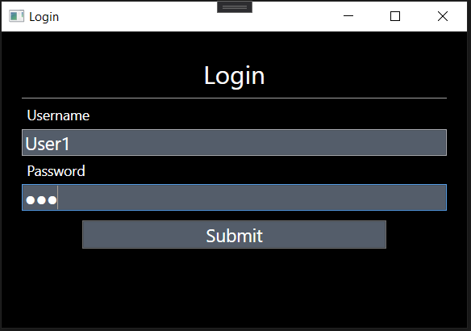

**GUI 1: Multiple Choice Grader Login Screen**

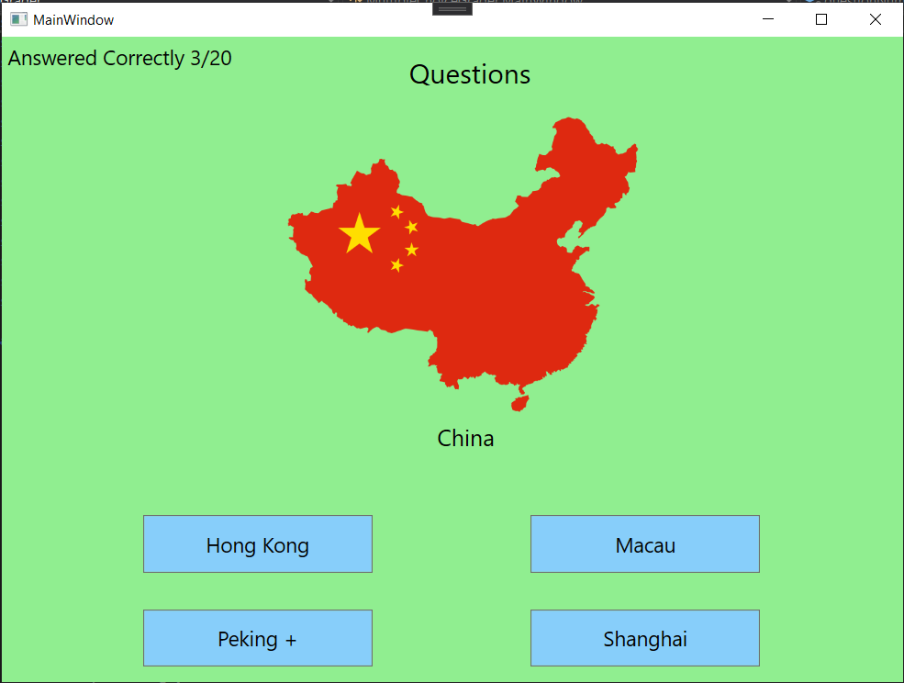 **GUI 2: Multiple Choice Grader Test Screen**



**GUI 3: Multiple Choice Grader Test Screen (End of test MCG display user score)**

**2-Histogram**

In this project, We displaying user info using datagridview and Gantt chart on a GUI. We implemented it as a Windows Forms Application and use the .NET framework. User scores giving in the Gant chart also we giving users Infos(user name, password, score, name, ID) in the datagridview . Users list by user score program displaying highest score users in the top.

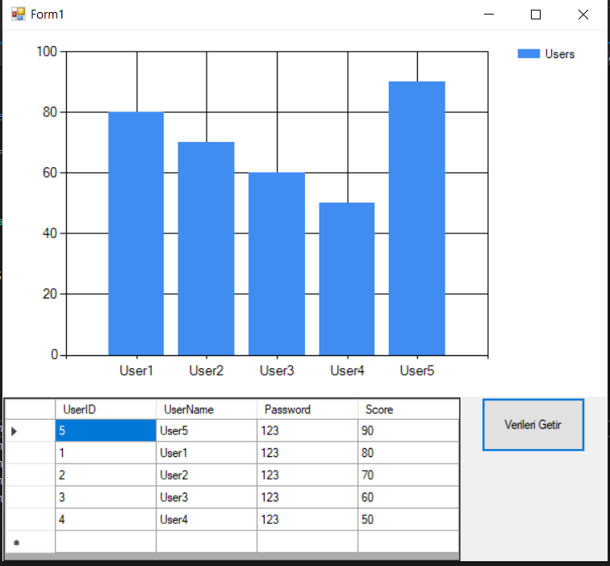

**GUI 1: Histogram**

**Object-Oriented Concepts**

We implemented the program in a way that I can benefit from OOP concepts to the maximum. Every object simulated in the game is represented by XAML class (buttons,button content,…) .

Window is an abstract class and there are two subclasses that inherit from it(LoginScreen, MainWindow). They all implement Window field, methods and objects according to their connections.

IQueryAmbient interface is implemented by Application class and IComponentConnector is implemented differently by two different classes which are related with Window class.

QuestionCategory is an abstract class and there are one subclasses that inherit from it(Geography). They all implement QuestionCategory field and methods according to their connections.

We use design patterns in our application.

